

Created by: Patrick Hurley & Gavin Kerrigan

**Rules**

# Onboarding:

### Goal:

Parties are under contract from kingdoms and empires to explore three giant dungeons created by the Game Master (referred to as GM for the rest of the manual), and to collect the most amount of coin. Each dungeon is explored sequentially, and for a limited amount of time.

### Setting:

Dungeons are scarcely understood magical spaces known to contain riches abundant enough to sustain the economies of kingdoms and even empires. Because of this, any information on the locations of dungeons is highly sought after by all sovereign nations. Dungeon collapses are a widely known phenomenon involving the destruction of a dungeon, and though they themselves are unpredictable, once a dungeon collapses, its reopening can be predicted through divination or magical study. The countries contracting our various adventurer parties are at tense political stalemates, facing economic troubles, or led by their own ambitions, and are all aware through investigation or espionage that three large dungeons are about to open sequentially. They each hire an adventurer party to dive into the dungeons for riches to ensure their nation prospers and their goals are realized.

### Game Master (GM):

GMs are responsible for both creating the dungeons with their elements and being the players in charge of how the games play out. There can be any amount of GMs in a single game, but for the rest of the manual, GMs will be referred to as singular even though their tasks can be divided in any way deemed necessary. However, a recommended way to divide the tasks is to have one run the dungeon exploration, one to run the shops and missions, and one or more to run combat.

Prior to playing the game, the GM is responsible for creating their dungeons from scratch in any way they want using the dungeon cards and systems provided. This includes, at minimum, the layout, events inside the dungeon, tasks, and contracts that the parties take on within the dungeon. The GM can make the dungeon any way they want and add their own content if they want such as a unique story, themes, systems, and whatever else the GM can think up to give them the freedom to make anything they really want to.

During the game, the GM is responsible for controlling the enemies in PvE combat, tie breaking, determining when a dungeon collapse will occur, and generally facilitating the overall game.

### Parties:

Players will form parties of either three or four players in order to explore the dungeons as a team. There could be anywhere between four to eight parties in one game.

Players can “magically” communicate with each other at any time, this “spell” requires no SP and has no restrictions of any sort. This applies to cross-party communication as well.

### Party Leader:

Each party will elect a party leader that will make the final decision on group decisions and act as a GM for their specific team, helping the rest of the team with stats, breaking ties decisions within the group, moving the party’s meeple, and generally supervising the rest of the team. It is recommended this team leader is someone with experience playing the game or as a game master in other games.

While the GM is the one who facilitates the game, the party leader facilitates each party and advocates for the party’s interest to the GM.

# Classes:

At the start of the game, each player in a party gets to pick a class. These classes can overlap per party. Each class has access to five moves and a basic attack they can throw out in a pinch.



Performer: Support class that buffs and heals fellow party members using their immaculate music skills.

Wizard: Heavy magic damage dealer who can hit single opponents and multiple targets incredibly hard along with healing teammates.

Conqueror: Heavy physical attacker who also is able to charge attacks and leave lasting damage for multiple turns.

Thief: Debuffs the opponent, supporting opponents by giving them HP and SP, and what’s a thief without being able to steal coins?

Knight: Focused on protecting party members from attacks while dealing both physical and magical damage to foes.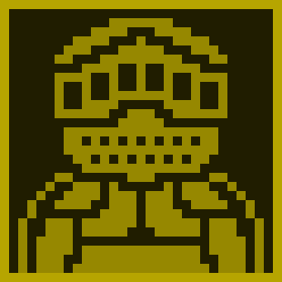

### Stats:

All players get 10 points to put into any stat that they choose and stats can go up to 10 at the highest.

* Strength: Determines physical damage
* Arcana: Determines magic damage
* Dexterity: Determines order at the start of battle and likelihood of dodging an attack
* Defense: Determines physical defense
* Willpower: Determines magic defense
* Luck: Determines tie breaking rolls along with out of battle situations such haggling prices, avoiding traps, and any situations the player attempts that the GM approves of

### 

### Leveling:

All party members start at level 0, and all xp earned is given to every party member.

Every 100 XP that a team gains will allow for every member of the party to level up. Levels let every member of the party increase any stat by one. Every two levels will allow players to upgrade the level of any of their moves by one. Move levels will increase an effect of the move by the defined point on the card.

Every level will increase the XP threshold required to level up by 25.

Whenever the party reaches level 50, players can not upgrade anymore stats, XP will instead give the party coin equal to the XP they gain above the maximum threshold, divided by 10.

# Outside the Dungeon

## Turns:

Parties can exit the dungeon at any time to freely trade with other parties that are outside, interact with the shop, accept new Tasks, and turn in missions. Exiting the dungeon for any amount of time will fully heal all party members.

Intermission turns occur the turn after a dungeon collapse completes, and the turn before parties enter the first dungeon. Each intermission turn between dungeon delves is a 15 minute turn where all parties are outside and can not enter any dungeon. During this turn, each party is given a contract specific to the next dungeon and specific to their party.

## Missions - Tasks and Contracts:

Missions are objectives that can task a party with anything from the extermination of multiple generic enemies or a single special enemy, to the retrieval of a specific relic from inside the dungeon. Missions can only be turned in once the party has left the dungeon, and the mission is complete. There are two types of Missions: Contracts and Tasks.

Contracts are missions given to parties by their sponsors during intermission periods. These missions are not chosen by the party, are specific to each party, and offer incredibly valuable rewards if completed. Parties that fail these incur no penalty, and they expire once the following intermission period ends.

Tasks are optional missions that parties can choose to accept from potential employers (Control). These missions are not specific to each party (though each task can only be accepted by a single party), and offer valuable rewards if completed. Tasks are typically accepted outside of a dungeon, and tasks that are accepted outside of a dungeon require a down-payment of coin to accept, with the down-payment being lost if the task is failed. The conditions for task failure are unique to each task, but most fail upon the conclusion of the next intermission period. If two or more parties want to accept the same task, they can bid on it by increasing their down payment on the task. The parties that lose the bid will have their down payment and bid returned to them fully and immediately, while the party that won the bid must complete the task to get their down payment and bid back.

## Purchasing Items:

Parties can choose to spend coin on equipment and consumables while outside the dungeon or at shop spaces within the dungeon. The list of always-purchasable items available at every shop is as follows:

* Food (Spent during movement, or heals 1hp) - 1 coin/2 item, infinite stock
* Health potion (Heals 15hp) - 4 coin/item, infinite stock
* Return Stone (Teleports entire party outside) - 25 coin/item, infinite stock

Certain items can also appear in shops for a limited time, or with a limited quantity. All items can be used in combat, and cost a full turn to use regardless of effect (Assuming they have one).

# Inside the Dungeon

## Turns:

Each turn lasts 15 minutes. Parties may use the first five minutes to determine their movement, and use the remaining 10 for combat. Trade, communication, and using consumables can be done at any time.

## Trade:

Parties that wish to trade with each other can only do so if they are in the same tile, adjacent tiles, the same room, or if one party is in a room and the other is in a tile adjacent to that room.

## Movement and Navigation:

Dungeons are unexplored labyrinths with (grid-based) maze-like interiors and their layouts are unknown to parties upon first entry. Parties must manually map the layouts of the dungeons they enter, or find maps inside. Parties can trade information on the layouts of dungeons, if they so choose.

### Movement Costs

Parties move as a single unit with the party discussing where they want to move at the start of each turn. The amount of food the party chooses to eat determines how far they can move, and if they heal.

* If the party does not eat any food, and has members that require food, it rolls a 1d4 -1 to determine how many tiles it can move through.
* If the party eats 1 food per food-consuming party member, it rolls a 1d4 to determine how many tiles it can move, and every party member is healed 5 health.
* If the party eats 2 food per food-consuming party member, it rolls 2d4 -1 to determine how many tiles it can move, and every party member is healed 5 health.

If the party chooses to eat no food, any party members that do not require food will still recover 5 health.

### Fog of War

The layout of the entire dungeon is visible to all adventurers upon entering. The contents of rooms, however, can only be viewed when direct line of sight on that room is established (The room must be in a cardinal direction, not obscured by a closed door or a wall).

### Rooms and Events

While exploring the dungeon, parties may enter rooms, which may have an event inside. If the room is not concealed by a door, parties can flip the room’s event card early to peek at what it is. Doors (if present) obscure the party’s vision until they are opened. When the party enters a room concealed by a door, they must flip that room’s card and interact with that event. There are three special card types that can appear in rooms, and all card types can be accompanied by battles that must be completed before the card can be interacted with. The card types are:

* Treasures: Draw a treasure card from the top of the deck. These cards can give additional effects to the single player holding them, and give a certain number of coins that are only added to your party’s coin total when selling them outside of the dungeon.
* Events: These GM designed traps will require a roll of stats to see if the party loses a decided amount of XP, coin, or health, or if the party passes and loses nothing. Events can also be opportunities for parties to accept additional unique Tasks while in the dungeon.
* Shops: Act as a way to access items found outside of the dungeon inside the dungeon, however, each item costs twice as much as on the surface, and items can not be sold.

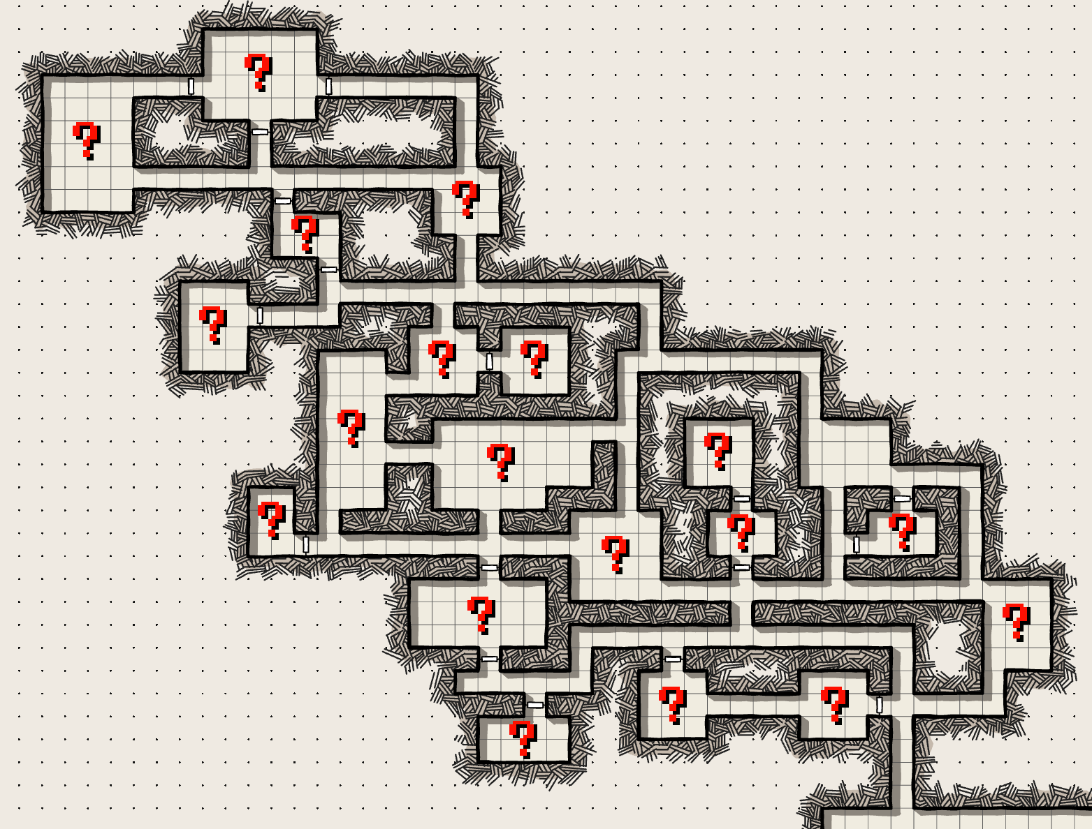

An example dungeon, fully mapped

## Combat:

Combat is turn-based with each player being able to do one action before moving on. Each combatant will go in order of highest to lowest dexterity, if two combatants have equal dexterity, the players controlling each combatant will roll with the higher roll going first during every turn that fight. Dexterity also plays into dodging moves with the target of an attack getting to roll a 1d20 to determine if an attack hits or not. The attack hits if the attack is higher than the target’s dexterity stat.

### Party v Enemies Combat:

A party will roll 1d6 movement check at the end of the movement section of their turn to determine if they have to commence an enemy encounter, unless they end movement in a room with a battle. A combat encounter begins if the party rolls either a one or a two, with any other roll outside special circumstances having no effect. Enemy count and type will be determined by taking a certain number of enemies from the enemy card pile equal to the number of players in a party plus the 1d6 roll for the encounter (outside of a Dungeon Collapse). For example, if a party of four rolls a 2 on their combat encounter roll, they need to fight 4 (Party size) + 2 (Roll) = 6 enemies. The GM will control each enemy and will choose which target to hit and which move to use. Enemies will also scale by team level with all of the stats being increased by one for every two party levels.

Combat continues until either a party wipe which makes the party lose 10 coins per enemy remaining and return to the entrance or an enemy wipe which gives party wide XP and coin which is determined by the enemy.

Parties are allowed to assist each other in fighting monsters. This will result in both parties receiving full XP from the battle, with the first party to enter combat deciding the share of gold they will give to the assisting party.

### Multi-Party Combat:

Party v Party encounters work very similarly to enemies with some key differences.

Battle commences if multiple parties cross each other on the same space, and at least one decides to fight another. The only parties involved in this fight will be the one(s) choosing to start the fight, the one(s) being attacked, and any who choose to assist or intervene for any reason. Parties can attack any member of any other party during party v party combat.

A party can not enter combat against another if either are fighting monsters, but they are allowed to assist each other in fighting monsters, as seen in the rules above. The parties can fight each other later in the same turn if they wish.

Wagering: XP and coin earned in battle is directly taken from the losing party. XP and coin gain from winning or losing the fight is determined by an agreed upon amount by both parties before battle. If parties can not agree on an amount parties can choose one member of their party to roll a tie breaking roll. XP lost is capped at a point where neither party can lose a level but coins can cause parties to go in the negative.

Finally, when a party loses they must move back 7 spaces that the winning party gets to determine.

### Knockout

When a party member’s HP reaches 0, they are knocked out. To bring a party member back into a fight, they must be healed above 0hp with an ability or a potion (item use is a full turn action). If combat ends with party members unconscious, they are resuscitated with 10hp regardless of the outcome of the battle.

## Dungeon Collapse:

Dungeons are magically unstable, and after sufficient disturbances, will begin to collapse. It is impossible to precisely predict when this will happen, but if a dungeon collapse is suspected to occur soon, or is in progress, adventurers are advised to evacuate as quickly as possible.

During a dungeon collapse, the very structure of the dungeon becomes hostile, and enemies roam more aggressively. Movement checks are modified to spawn enemy parties on rolls of 1, 2, and 3, and to spawn traps under the party’s feet on rolls of 4. Combat encounters under a dungeon collapse behave as normal, and traps must be evaded via skill checks or one or many adventurers in the party will face penalties.

Any parties still inside the dungeon once it finishes collapsing are magically rescued by their contractors, avoiding death. This is a costly process, and will result in that party losing 75 coins.

# Game Conclusion:

The game ends after the intermission period following the third dungeon’s collapse. At that time, each party’s coins are tallied and a winner is announced.

If two or more parties wish to work together, they can force a draw if all parties involved have an equal amount of coins at the end of the game, and no other party has a larger amount of coins than the ones involved in forcing the draw.

# 

# Homebrew:

We encourage both the players and the GM to experiment and really make the game their own with additions to the base game in any way they feel like it. But to really get started, here are just a few ideas:

* **Character Importing:** Try importing your characters from other tabletop roleplaying games and use it as a way to put different groups against each other. You can even try balancing different moves from those games to work within the combat of For Treasure and Glory.
* **Additions to combat:** There are a lot of ways you can make combat more interesting, maybe even by just adding new or classes that can fit the story you want to tell or the dungeon you are creating.
* **Shrink or Expand the game:** Do you find yourself wanting more or less players within the game? That’s no problem with the tools given within the game! You can always alter the game to make it 4 or 8 players with partnerships or players by themselves rather than parties. Make it an even bigger mega game by creating even more parties within one dungeon! Maybe even get funky with how parties are set up and make it two giant parties against one another or go the other extreme and have a bunch of players fend for themselves.
* **Worldbuilding:** Who are the interests contracting our adventurers? Are they enemies? Will these contractors reward their parties for sabotaging their enemies, or even give them contracts to do so?
* **Dungeon-wide events:** Does the dungeon entrance cave-in during the expedition, preventing parties from leaving for a few turns? Does the food supply brought into the dungeon spoil, leaving adventurers hungry? Dungeon-wide events can serve to add tension to an otherwise calm moment, and can drive parties into conflict with each other.

**Assets**

# Character sheets:

# Printable online

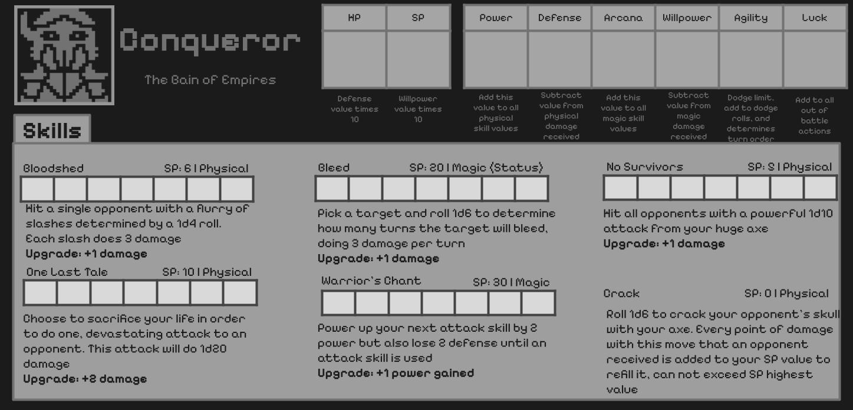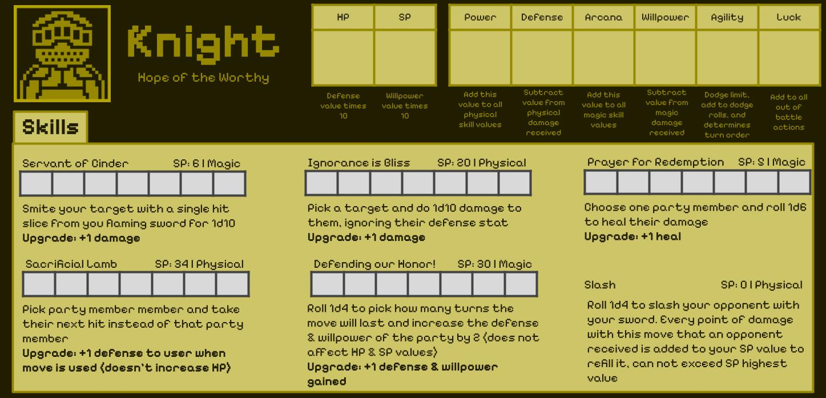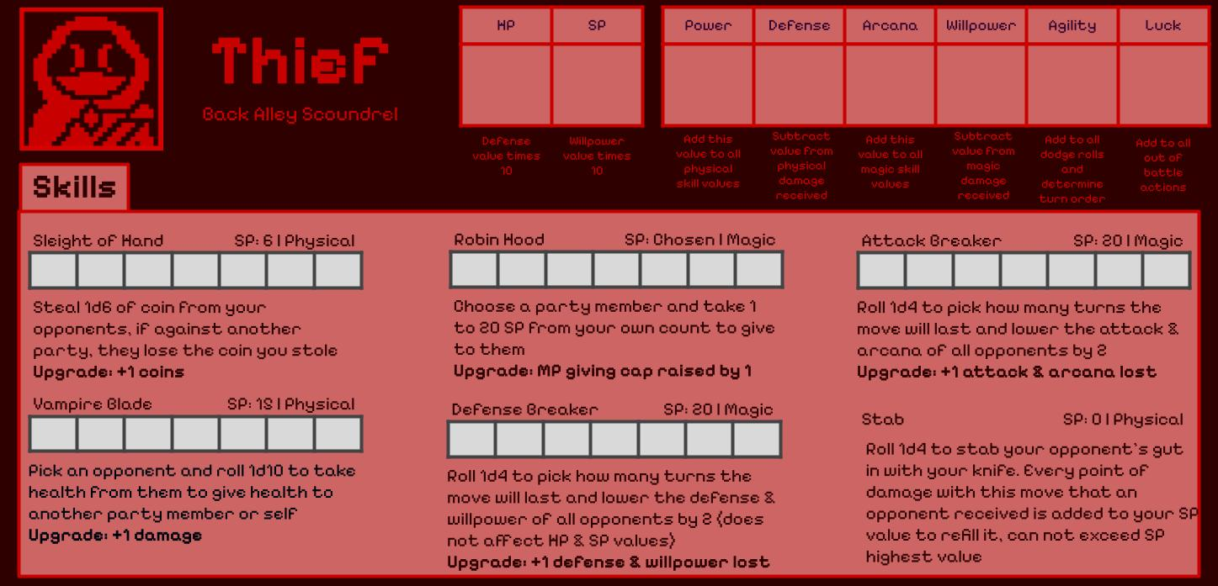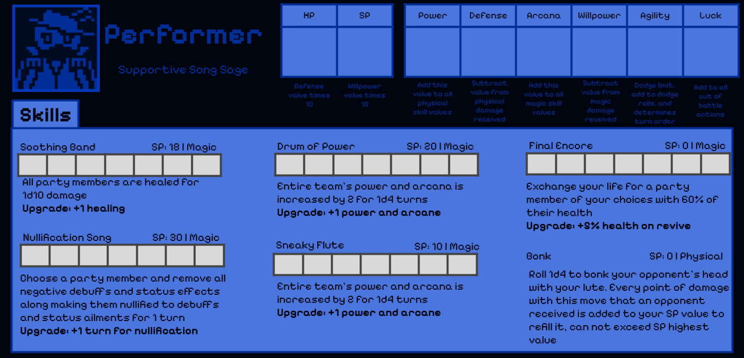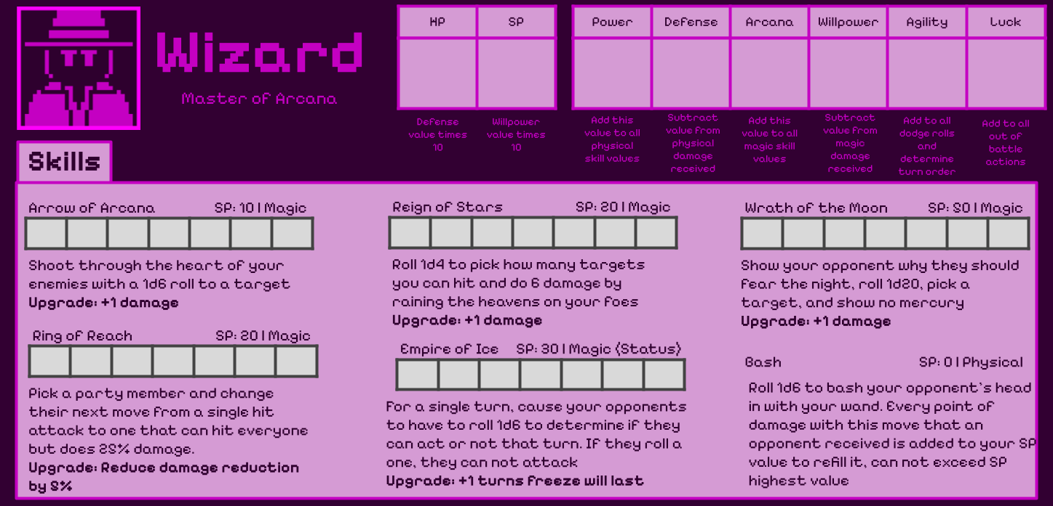

# Enemies:

5 Arachnid

2 Chimera

6 Fairy

6 Gnome

6 Goblin

2 Golem

4 Oni

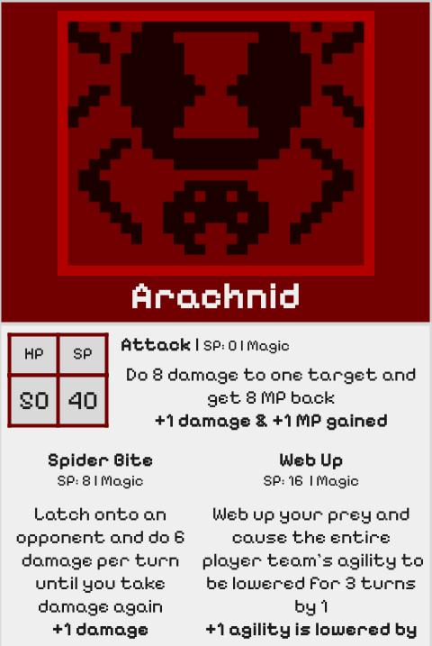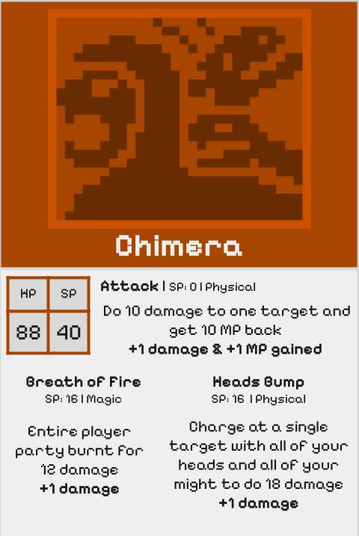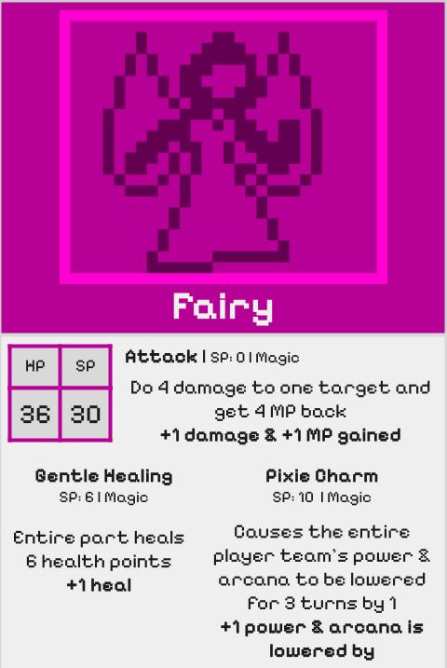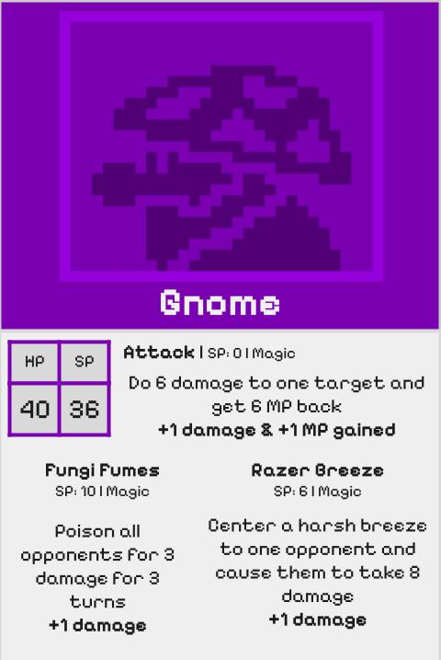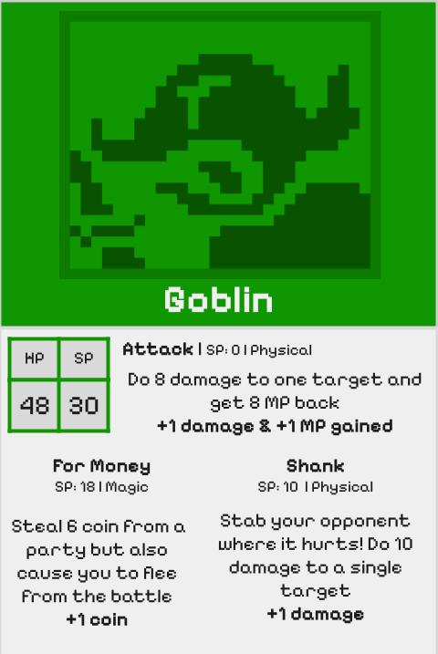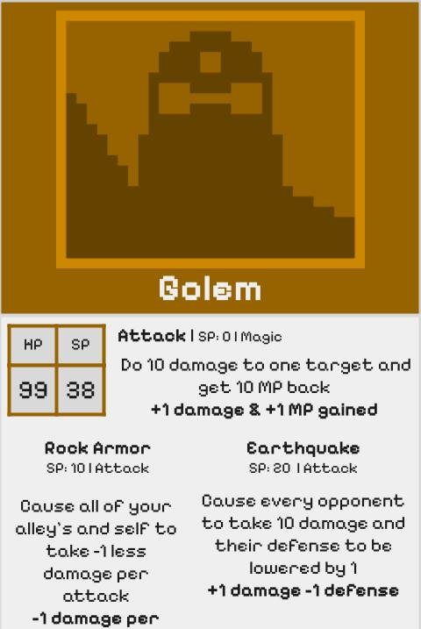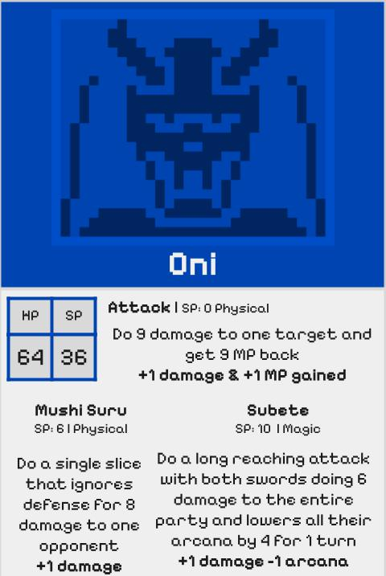

# 

# Dungeon Cards:

20 of each card are included in the game but more can be printed online if needed

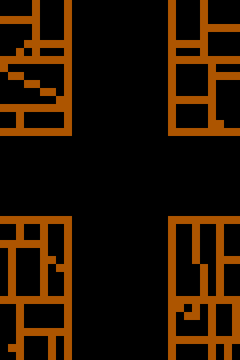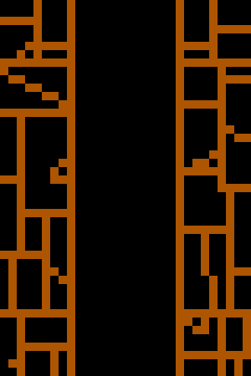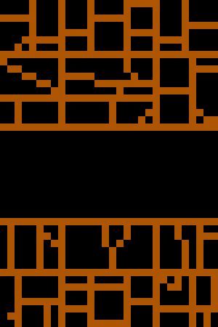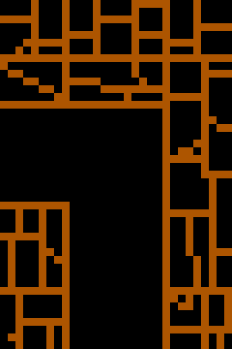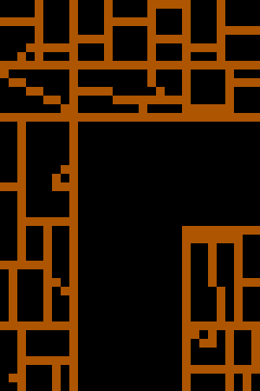

# 

# Tiles: (Event, Shop, Treasure)

# *Game includes 5 of each tile type

# 

# Everything Tiles:

# Used for creating missions and anything else the GM wants

# 

# Treasure Cards:

15 Coin Pouch

1 King’s Crown

5 Diamond

8 Single Coin

8 Chest

6 Ring of Asceticism

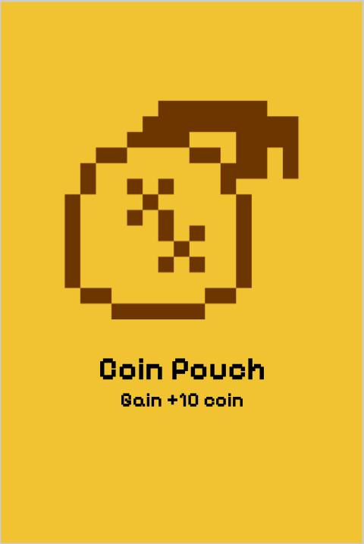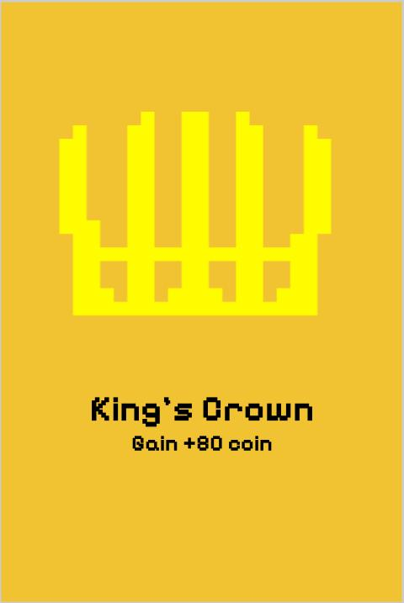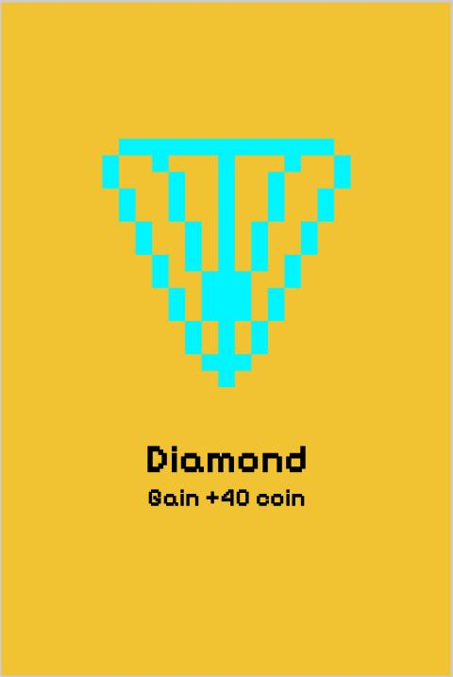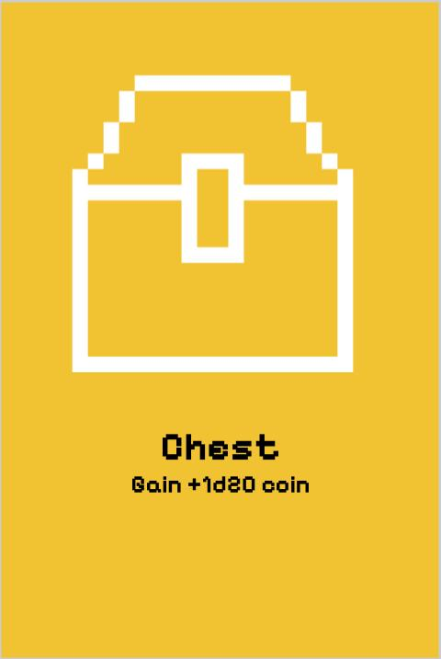

# 

# Additional Pieces included:

* 8 different colored meeples to represent player pieces on the board (red, orange, yellow, green, blue, purple, pink, gray)
* 8 sets of dice matching the color of each team
  + D4
  + D6
  + D10
  + D20
* Printed set of rules